**Algebra I**

**Ms. Hill**

**Email address: hillbr@boe.richmond.k12.ga.us**

**Phone Number: (706)-592-2089 Planning Period: 1st period**

**Course Description and Objectives**

**Algebra I** is the first course in a sequence of three required high school courses designed to ensure career and college readiness. The course represents a discrete study of algebra with correlated statistics applications.

The fundamental purpose of Algebra I is to formalize and extend the mathematics that students learned in the middle grades. The critical areas, organized into units, deepen and extend understanding of functions by comparing and contrasting linear, quadratic, and exponential phenomena. The Mathematical Practice Standards apply throughout each course and, together with the content standards, prescribe that students experience mathematics as a coherent, useful, and logical subject that makes use of their ability to make sense of problem situations. The pacing suggested below will allow students to gain a foundation in linear, quadratic, and exponential functions before they are brought together to be compared/contrasted in Unit 5. Although units 2, 3, and 4 look lengthy in terms of the number of standards, only their application to one function type per unit will be addressed. As key characteristics of functions are introduced in unit 2 and revisited within units 3, 4, and 5, students will gain a deeper understanding of such concepts as domain and range, intercepts, increasing/decreasing, relative maximum/minimum, symmetry, end behavior, and the effect of function parameters. Unit 5 will also provide an excellent opportunity for review of many concepts in preparation for the administration of the Georgia Milestones EOC assessment.

Unit 1 (4 – 5 weeks) Relationships between Quantities and Expressions

Unit 2 (6 – 7 weeks) Reasoning with Linear Equations and Inequalities

Unit 3 (7 – 8 weeks) Modeling and Analyzing QuadraticFunctions

Unit 4 (7 – 8 weeks) Modeling and Analyzing Exponential Functions

Unit 5 (3 – 4 weeks) Comparing and Contrasting Functions

Unit 6 (3 – 4 weeks) DescribingData

**Assignments and Absences**

Students will receive a variety of assignments designed to enhance their learning. If a student is absent, the student is responsible for the missed assignment. Students who have an excused absence will be allowed five days to turn in the missed assignment. No work will be accepted after five days. **It is Students responsibility to contact me if they are having trouble or needs assistance.**

**Course Assessment Plan/Grading Scale:**This course will include many formative assessments and labs. The course will also include four countywide common assessments.

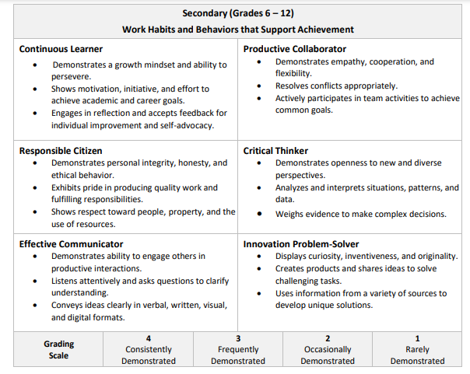

       Major Assignment 60%

Minor Assignments 40%

**School Expectations**

Follow all school rules and policies (P.R.I.D.E – PBIS).

* + P – Positive
  + R – Respectful
  + I – Innovative
  + D – Determined
  + E – Excellence

**Classroom Expectations**

1. Be prepared for class.

* + Students should arrive 5-10 minutes earlier to ensure that there are not technological issues. All in person meetings will be held in Teams.
  + **All meetings will be recorded**, this allows students to go back and review the lesson learned.
  + Students are expected to have camera’s on and be present for all in person lessons. Camera’s are to be on, and Students should be sitting in an upright position. Example: desk and chair, or table and chair
  + Students should mute mics expect when called upon.

2. Be Respectful.

3. Be Responsible.

4. Be Positive.

5. Phones should be turned off or silenced and put in the “Charging Station”.

**Consequences**

When you choose not to follow these expectations, one or more of the following will happen:

1. A warning. Warnings may be verbal, non-verbal, or written.

2. Phone Call home.

3. Conference with parents/guardians.

4. Conference with Principal.

All consequences will be aligned with the HHS school wide discipline plan.

**Interrupting class lesson**

1. **A warning and mic will be turned off**
2. **Student will be kicked of the lesson and parent will be called**
3. **Parent, teacher and Student video conference will take place**
4. **Conference with the Principle**

**Course Suggested Materials Students may take notes online use desmos**

1 Large Three-ring binder Pencils --- mechanical pencils preferred

1 Packages of Dividers Highlighters Loose Leaf Paper Headphones

**Conferences**

The primary goal is to meet the developmental needs of each student; therefore, student progress during each grading period will be closely monitored. A **Parent conference should be scheduled for all students earning D’s and F’s at the end of each nine weeks grading period.**

**In order to schedule a conference with your teachers, please contact the Guidance Office 706-592-208**

**Remind Class Code:**

Text @HillAlgeb to the number 81010

**KEEP THIS SYLLABUS IN THE FRONT OF YOUR MATH NOTEBOOK**

**FOR THE DURATION OF THE FIRST SEMESTER.**

**Please fill out the Microsoft forms found in Canvas under Intro Section and check you have read the syllabus.**